**Daily Scrum or Standup Meeting**

Team name: Group 2

Scrum Master: Max Edwards

Date:____________March 16 2023___________________

| **Team Member** | **What did you do since the last scrum?** | **What do you plan to do before the next scrum?** | **What obstacles do you have?** |
| --- | --- | --- | --- |
| Satchell Fausett | Reviewed the code  Add images to static | Write remaining unit tests | Fiance and weekend plans |
| Jared Hansen | Made a brick game | Look at what docs will be needed | Object oriented |
| Chase Miller | Unit tested | Fix and write unit test | Lifting at the ARC and bear lake |
| Max Edwards | Delete button | Component | I started |
|  |  |  |  |

# Burndown

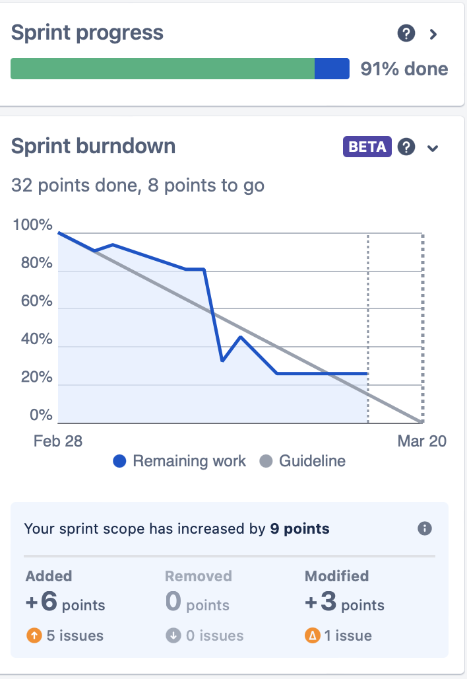

# Screenshot of you project board

